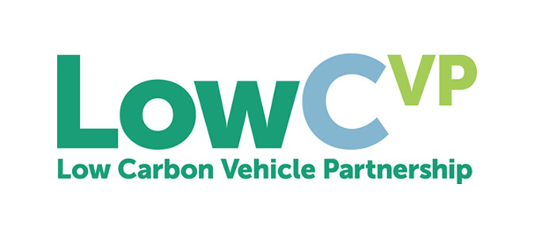
LowCVP News Release
12 March 2018
Leading speakers to focus on industrial opportunities of ‘green transport revolution’ at LowCVP ‘Moving North’ Conference

The Low Carbon Vehicle Partnership’s (LowCVP) 2018 ‘Moving North’ Conference, opening with a keynote address by the Mayor of Greater Manchester, Andy Burnham, will focus on the challenge of cutting carbon emissions and air pollution, and seizing the business opportunities for automotive and fuel supply companies in the Northern Powerhouse.
The event, on Thursday 12 April 2018, is being held in association with the Mayor of Greater Manchester, the Northern Automotive Alliance (NAA) and Transport for Greater Manchester (TfGM). It is supported by Manchester Metropolitan University and sponsored by GEFCO and Uber.
The conference features a range of high profile speakers including:
• Andy Burnham, Mayor of Greater Manchester
• Mike Hawes, Chief Executive, Society of Motor Manufacturers and Traders (SMMT)
• Ian Constance, Chief Executive, Advanced Propulsion Centre (APC)
• Lawrence Davies MBE, Chief Executive, Automotive Investment Organisation (AIO)
• Jon Lamonte, Chief Executive, Transport for Greater Manchester (TfGM)
• Andy Eastlake, Managing Director, Low Carbon Vehicle Partnership (LowCVP)
• Carol Holden OBE, Chief Executive, Northern Automotive Alliance (NAA)
• Jon King, Business Development Consultant, Warwick Manufacturing Group (WMG)
• Dave Roberts, Director, Smart Interventions, EA Technology.
‘Moving North’ will look at the future of transport in the Northern Powerhouse region (and beyond) – a future that will be driven by ever-tighter regulation of carbon dioxide emissions and pollutants which damage air quality – and the resulting opportunities for businesses in the automotive, fuels and related sectors.
The event, and the drinks reception which follows the conference, will also be an important networking opportunity, as it will bring together a number of different sectors, including the automotive and energy industries, governmental/public sector organisations, ‘new mobility’ companies and other stakeholders.
Andy Eastlake, Managing Director, Low Carbon Vehicle Partnership, comments: “This is the LowCVP’s first conference in Manchester and I am delighted that we have such an impressive line-up of high profile and knowledgeable speakers. Reducing CO₂ emissions and improving air quality are two key items of focus for regions around the UK.
“The conference will provide an opportunity to learn more about these issues in Manchester and the wider Northern Powerhouse area, and the resulting opportunities for businesses in the region. I hope that the event will help to facilitate fruitful new relationships and partnerships to accelerate solutions in the area of low emission road transport.”
Carol Holden OBE, Chief Executive, Northern Automotive Alliance (NAA), adds “The automotive industry is changing at a faster rate than at any previous time in its history. This offers opportunities for existing automotive supply chain companies, but also for companies that currently don’t supply into automotive – from sectors such as energy and technology.
“Businesses introducing innovative disruptive technologies have a real chance to break through into the mainstream. The Moving North Conference will highlight aspects of transport where new products, services and approaches are needed.”
Moving North is a ticketed event, which is free to members of the LowCVP. There is a 25% discount for members of the Northern Automotive Alliance. Non-members are invited at the standard price of £100.
There are also some indoor exhibition spaces, a small number of outside spaces for vehicles, and a very limited number of sponsorship opportunities.
For more information visit www.lowcvp.org.uk/events/North2018.htm
Ends
NOTES TO EDITORS
The LowCVP (www.lowcvp.org.uk), which was established in 2003, is a public-private partnership that exists to accelerate a sustainable shift to lower carbon vehicles and fuels and create opportunities for UK businesses. Nearly 200 organisations are engaged from diverse backgrounds, including automotive and fuel supply chains, government, vehicle users, academics, environment groups and others. Follow the LowCVP on Twitter: @theLowCVP
The LowCVP’s Moving North Conference is sponsored by GEFCO and Uber

About GEFCO
From supply to distribution, GEFCO provides global and integrated management and optimisation of the logistics chain for its industrial customers. GEFCO has applied an acquired expertise in automotive logistics - one of the most demanding sectors - in order to respond to the globalisation of industrial flows and the needs of its international customers that face global and complex challenges. GEFCO has a leading private land transport network, with 80 hubs and 65 logistics platforms worldwide. This global coverage allows it to design optimised transport plans that create added-value for its industrial customers.

About Uber
Uber is a technology company - and a smartphone app - that allows people to tap a button and book a safe, affordable and reliable journey with a licensed private hire driver in over 40 UK towns and cities. Globally, the Uber app is available in 600 cities across 75 countries. Uber believes in a future where every car journey is a shared journey, made in a highly efficient vehicle - reducing congestion and improving air quality. To move towards this goal - and help tackle poor air quality in UK cities - Uber recently announced a Clean Air Plan which includes a commitment to having exclusively hybrid and electric vehicles available on the app by 2022.

For further information about the LowCVP Moving North event, please contact:
Neil Wallis, Head of Communications, LowCVP
neil.wallis@lowcvp.org.uk Tel: 0207 304 6806 Mob: 07974 255720

Paul Clarke
paul.clarke@automotivecomms.co.uk Tel: 0161 980 6436 Mob: 07866 770029

